**Laboratory Activity**

**Web Systems and Technology**

**Midterm**

Procedure:

* Open your individual unit and check your current PHP version using the command prompt see sample image below : Write the command in the black provided

_____________________________________________

* Then open the XAMPP control panel (see image)

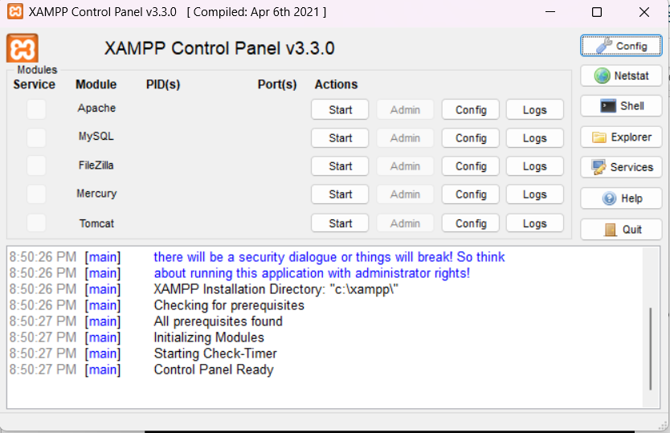

Make sure to click the Start button to open the Apache and MySQL

* Once it green your server is now running

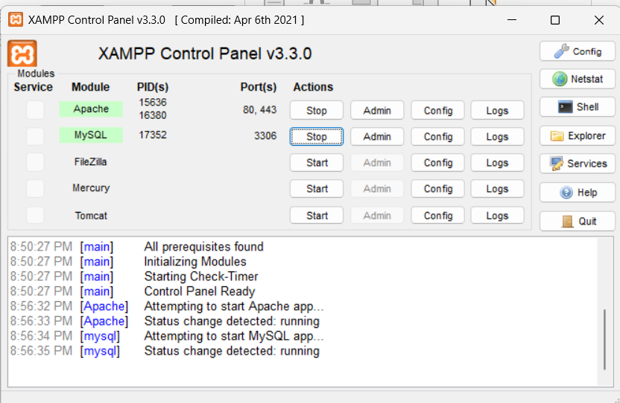

* Make sure to check the ports of Apache and MySQL as follows

* Your now ready to test your server
* Access the XAMPP dashboard in a browser
  + Open your preferred web browser and type http://localhost into the address bar and press **Enter**.
  + If XAMPP is working correctly, you will see the XAMPP welcome page, which confirms the Apache web server is running.

* + Alternatively, you can type http://127.0.0.1 to get the same result.
* Next, open your VS code app if the following Extension are available and properly installed
  + PHP server
  + Live server
  + PHP intelephense

* Once installed start your first PHP code

**First thing first create a folder inside your XAMPP**

* **Locate your root folder**. Open the XAMPP Control Panel and click the **Explorer** button to navigate to your installation directory, typically **C:\xampp\ on Windows**.

* **Find htdocs**. Open the htdocs folder. This is the root directory for all your web projects.

* **Create a project folder**. Create a new folder inside htdocs for your project (e.g., C:\xampp\htdocs\MyWebsite(any name you set)).
* **After creating the Filename inside htdocs, open your VS CODE app then**
* **Then locate this folder as show in the image below**

* **Save your projects**
  + you need to save your files in the correct directory.
* Create at least one sample code using the following.
  + Concatenate String

* + Math Functions
  + Loops
  + Constants
  + PHP Superglobals
  + Sample Form Handling

Note: Don’t forget to save your sample with PHP extension (e.g index.php)

* Display an output for each sample
  + **Access your project**. To view your website, go to your browser then type  <http://localhost/MyWebsite> (or the name you set)  . If you created a specific file, such as index.php, you would visit <http://localhost/MyWebsite/index.php> (or the filename you saved)

Activity 2 – Laboratory Activity

<!DOCTYPE html>

<html>

<head>

    <title>Simple PHP Example</title>

</head>

<body>

<h2>HELLO, PEDE NA PO BA UMUWI?</h2>

<form method="post" action="<?php echo $_SERVER['PHP_SELF']; ?>">

    Enter a number: <input type="number" name="number">

    <input type="submit" value="Submit">

</form>

<?php

define("PI", 3.14);

function getCircleArea($radius) {

    return PI * $radius * $radius;

}

if ($_SERVER["REQUEST_METHOD"] == "POST") {

    $num = $_POST["number"];

    if (!empty($num)) {

        echo "<h3>You entered: $num</h3>";

        $area = getCircleArea($num);

        echo "Area of a circle with radius $num is: " . $area . "<br><br>";

        echo "Let's count from 1 to $num:<br>";

        for ($i = 1; $i <= $num; $i++) {

            echo $i . " ";

        }

    } else {

        echo "<p style='color:red;'>Please enter a number!</p>";

    }

}

echo "<hr>";

echo "Example of addition:<br>";

$x = 1111;

$y = 1023;

$z = $x % $y;

echo "$x % $y = $z";

?>

</body>

</html>

